Eclipse + MinGW + Qt开发环境设置

1.下载Eclipse
目前Eclipse+CDT已经可以集成下载了，好像优化过了，速度还比较快。
下载的地址是：http://www.qtsoftware.com/developer/eclipse-integration，选择“Eclipse IDE for C/C++ Developers ”下载即可。
2.下载MinGW
1) 自动安装MinGW
到网站http://sourceforge.net/project/showfiles.php?group_id=2435，下载“Automated MinGW Installer”
下载完毕以后，点击运行MinGW-5.1.3.exe应用程序，选择安装目录，它便会自动通过网站来下载需要的文件。
2) 手工安装MinGW
到网站http://sourceforge.net/project/showfiles.php?group_id=2435，下载如下安装包：
binutils-2.17.50-20070129-1.tar.gz
mingw-runtime-3.13.tar.gz
mingw-utils-0.3.tar.gz
mingw32-make-3.81-2.tar.gz
gcc-core-3.4.5-20060117-1.tar.gz
gcc-g++-3.4.5-20060117-1.tar.gz
w32api-3.10.tar.gz
gdb-6.6.tar.tar
按顺序减压到一个文件夹内部（减压gdb的时候，会提示文件有冲突，直接覆盖即可）。
3) 将刚才减压的目录添加到环境变量PATH中
如果减压到d:\MinGW，那么添加“d:\MinGW\bin”到系统目录中即可。
3.下载Qt及Eclipse插件
到Qt网站（http://trolltech.com/developer/downloads/qt），直接下载qt-win-opensource-4.3.2-mingw.exe，安装即可。
下载Eclipse插件的地址：http://trolltech.com/developer/downloads/qt/eclipse-integration-download
4.安装qt-eclipse-integration-win32-1.0.0.exe
没什么好说的，就是选对Eclipse和MinGW的路径即可。
5.开发举例：
1）.设置eclipse
通过菜单“Window” -> "Preferences..."，进入参数设置框，在Qt里面添加我们刚才安装的位置和版本号，如下图：
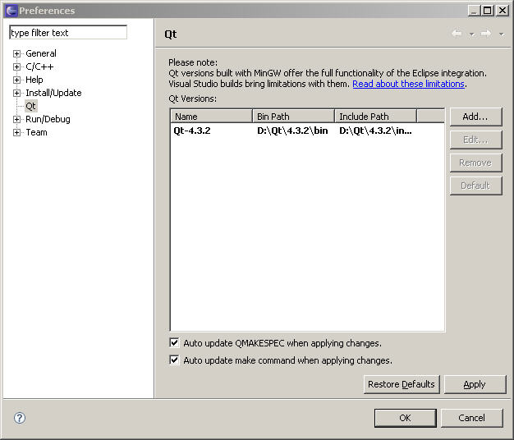
2) 建立Qt工程
“File” -> "New" -> "New Project"
在Qt目录下面选择“Qt Gui Project”, "Next", 然后输入工程名字，剩下的只需要一路取默认值即可。
3) 在窗体上添加按钮
双击工程里面的ui文件,打开窗体编辑窗口.
在菜单"Window" -> "Show View" -> "Other..."
选择"Qt C++ Widget Box",点击"OK",就可以打开控件窗口了,如下图:
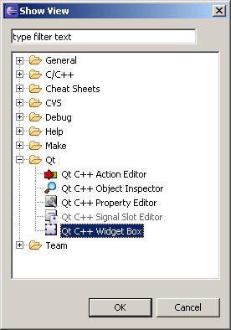
以同样方式打开"Qt C++ Signal Slot Editor"窗口.
4) 在窗口上放置两个按钮,在按钮上右键修改objectName和text.
两个的objectName分别是:"Button1","Button2:".
text分别是:"Show Box", "Close"
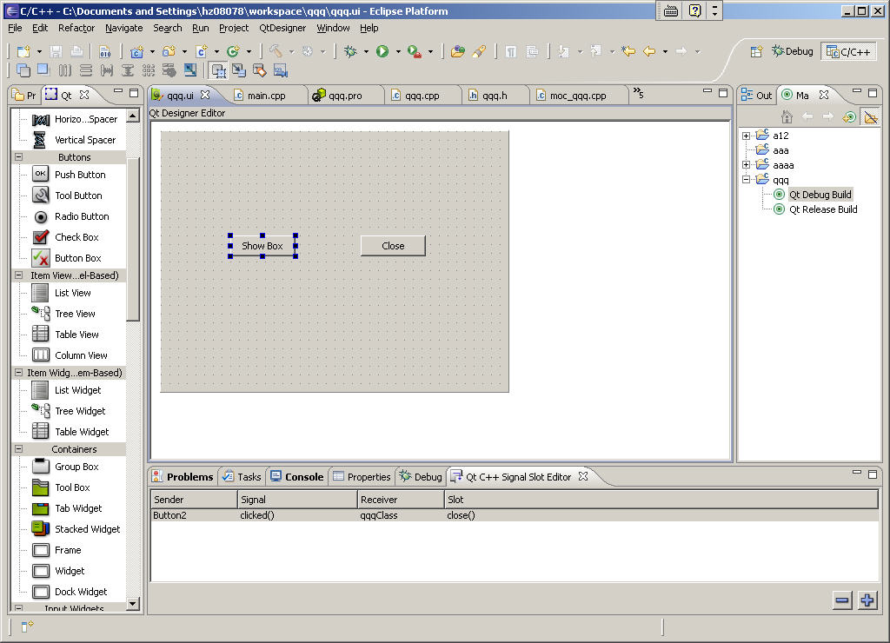
5) 添加按钮事件
在"Qt C++ Signal Slot Editor"窗口里面,单击"+"图标,这时候再窗口里面出现一行内容.
将双击""，选择“Button2”；双击“”,选择"clicked()";双击"",选择"close()".
打开主窗口类头文件(我的是qqq.h), 添加信号响应部分和函数:
private slots:
void on_Button1_clicked();
这个函数的格式必须是:on_控件名_事件类型()
在cpp文件里面，添加头文件及函数实体：
#include
...
void qqq::on_Button1_clicked()
{
QMessageBox box(this);
box.setText("Hello World!");
box.exec();
}
6) 在Eclipse里面，编译运行程序即可。
效果如下：
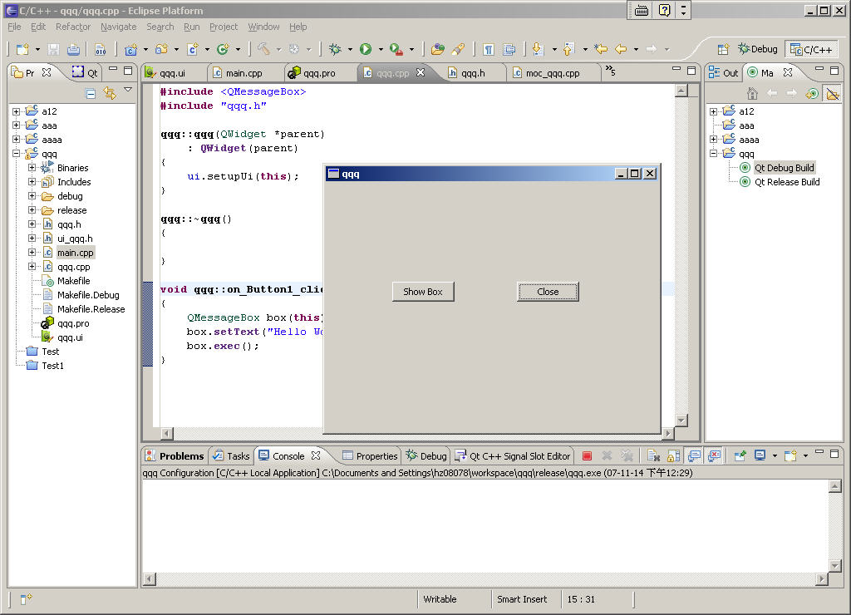
注意：
1.默认的Qt for MinGW的安装，是不安装调试库的，如需运行Debug模式，按照下面的方法编译调试库，
在Qt的bin目录里面，用命令：
qtvars.bat compile_debug
来编译调试库。
需要大约3G的磁盘空间，大约4个小时的编译时间。
2.如果安装完qt-eclipse-integration-win32-1.0.0.exe，发现第二次启动Eclipse不成功的话，
到Eclipse的plugins目录下，删除文件“com.trolltech.qtcppstartup_1.0.0.jar”即可。

开发工具与环境( g++, Eclipse , qt-4.4.3 )我的嵌入式开发之路
2009年01月14日 星期三 09:53
文章摘要：
１，windows,linux平台下安装使用eclipse + QT4.4.3开发环境
２，windows,linux新建project时的配置(不使用QT预置项目类型，而是手工配置）
使用Eclipse开发平台的原因：
由于要在windows/Linux上开发，希望统一开发工具．
以前开发QT3时，界面开发使用QT自带的designer, 程序也可以在designer里面全部完成．有时也用一些轻量级的编辑工具，如windows下FlexEdit(www.xuyibo.org下载，相当不错，尤其是自动分析C++源文件中的类，方法，快速导航功能极方便)，Linux下的vi（不论何时，VI是不能忘记的，尤其是出差时，linux/unix下唯一能保证有的就是它了）．
后来使用SlickEdit开发工具，分析代码与写代码都相当方便．与QT designer配合使用真的是很方便．
Qt4的出现，qt designer的功能大大减低，需要新的集成开发工具．在Windows下，vs2005+Visual Assist X + QT也是相当方便的，只是无法跨平台．所以趁着学QT4的，试试eclipse集成开发工具．
一 Windows平台安装 (Eclipse , c++, qt4, fortran)
1.1 所需文件:
DEV-CPP4.9.9.2.exe --> 要用其集成的MinGW开发环境(make and g++)
qt-win-opensource-4.4.3-mingw.exe --> QT的开源版本
eclipse-cpp-ganymede-SR1-win32.zip --> 集成了CDT插件的Eclipse
qt-eclipse-integration-win32-1.4.0.exe --> 把QT集成到Eclipse中去的.

1.2 安装过程
DEV-CPP4.9.9.2.exe安装到d:\qt\dev-cpp目录
qt-win-opensource-4.4.3-mingw.exe安装到d:\qt\4.4.3目录 (安装过程需要指定MinGW的位置,把默认的c:\MinGW改为d:\qt\dev-cpp即可)
eclipse-cpp-ganymede-SR1-win32.zip 直接解压到d:\eclipse即可.(需要安装jre环境后才能运行,本人用1.6)
qt-eclipse-integration-win32-1.4.0.exe 安装过程中需要指定eclipse与MinGW的位置,按上面的实际安装目录修改. 安装到d:\qt\trolltech\eclipse

1.3 编辑运行QT4程序
1.3.1 命令行编译与运行QT程序,有三种方法:
法一: 需要通过"开始"->"程序"->"Qt by Nokia v4.4.3 (OpenSource)" ->"Qt 4.4.3 Command Prompt" 打开DOS命令行窗口,再编译运行;
法二: 打开任意一个Dos窗口, 执行一下 d:\qt\4.4.3\bin/qtvars.bat ,设置相应环境变量.
法三: 修改系统环境变量:
新建环境变量 QTDIR,值为d:\Qt\4.4.3
新建环境变量 QMAKESPEC , 值为 win32-g++
修改原path变量,在原值最前面增加d:\Qt\4.4.3\bin;D:\qt\DEV-CPP\bin;%SystemRoot%\System32;
源代码编辑工具可以使用dev-c++, editplus, FlexEdit等
1.3.2 使用Eclipse编辑,编译,运行
这里要注意, 安装qt-eclipse-integration-win32-1.4.0.exe自动生成的开始菜单项"Qt Eclipse Integration v1.4.0" -> "Start Eclipse with MinGW" 有问题. 需要编辑d:\qt\trolltech\eclipse\start.bat,把QT需要的环境变量设置语句加入,完整的如下:
echo Setting up a MinGW/Qt only environment...
echo -- QTDIR set to d:\Qt\4.4.3
echo -- PATH set to d:\Qt\4.4.3\bin
echo -- Adding D:\qt\DEV-CPP\bin to PATH
echo -- Adding %SystemRoot%\System32 to PATH
echo -- QMAKESPEC set to win32-g++
set QTDIR=d:\Qt\4.4.3
set PATH=d:\Qt\4.4.3\bin
set PATH=%PATH%;D:\qt\DEV-CPP\bin
set PATH=%PATH%;%SystemRoot%\System32
set QMAKESPEC=win32-g++
echo Starting eclipse...
call "D:\eclipse\eclipse.exe" -clean

启动eclipse后, "File" -> "new" -> "other" ,选择QT下面的某一个项目,如"QT Console project"或"QT GUI project", 然后指定项目名, 就可以使用菜单"project" ->"build all"进行编译了. 默认情况下生成debug格式.
运行,需要生成运行配置. "run" -> "run configurations..." , 双击"C++ local application"在下面生成一个新的配置"new_configuration", 在右侧点"project"后的"browse..."选择刚才新建的项目名, 点"c/c++ application"后"search project..." 找到可执行文件, 然后就可以点击"run"运行了. (注意, 如果上面新建的是qt console project, 需要在建立项目后, 点"project" ->"properties" , 双击左侧"c/c++ Make project" , 然后在右侧选择"binary parser"标签, 选中"elf parse"与"pe windows parser". 否则在"search project..." 时会找不到可执行文件. )

1.4 让eclipse支持fortran:
下载photran40b4-master.zip
启 动eclipse, 菜单"help" -> "software updates" ,选中"Available Software"标签, "Add Site..." , 在弹出的对话框中点"Archive...", 找到硬盘上的photran40b4-master.zip,按提示完成安装,重启eclipse,就发现在File,New时多了对Fortran的支 持.

====================
二 Linux平台安装 (Eclipse ,c++, qt4, fortran)
1, 安装JDK1.6.bin,并配置环境变量.
安装目录/data/opt/jdk1.6.0_01
修改/etc/profile, 在最后添加java的环境变量:
JAVA_HOME=/data/opt/jdk1.6.0_01
JAVA_BIN=/data/opt/jdk1.6.0_01/bin
PATH=$PATH:$JAVA_HOME/bin
CLASSPATH=.:$JAVA_HOME/lib/dt.jar:$JAVA_HOME/lib/tools.jar
export JAVA_HOME JAVA_BIN PATH CLASSPATH
2, 安装eclipse
解压eclipse-cpp-ganymede-SR1-linux-gtk.tar.gz到/data/opt/下
3, 编译安装qt
$tar jxvf qt-x11-opensource-src-4.4.3.tar.bz2
$cd qt-x11-opensource-src-4.4.3
$./configure -prefix /data/opt/qt-4.4.3 -no-libtiff
$make && make install
$vi /data/opt/qt-4.4.3/setqt4 (以后在需要编译QT程序时,执行source setqt4就可以设置好环境变量)
export QTDIR=/data/opt/qt-4.4.3
export PATH=$QTDIR/bin:$PATH
export LD_LIBRARY_PATH=$QTDIR/lib:$LD_LIBRARY_PATH
4, 让eclipse集成QT
$cd /data/opt/eclipse
$tar zxvf qt-eclipse-integration-linux.x86-gcc3.3-1.4.0.tar.gz
5, 让eclipse集成fortran支持,方法与windows下相同, 使用的文件也相同

6, 安装apache2,mysql5,php5,svn服务器
7, 安装slickedit, matlab7

=====windows平台，eclipse中编写QT程序==2008-10-13=====
一：在eclipse中编写一般c++程序
1, file->new ->other ->展开C++下的C++ Project ->不选中"Show project types and toolchains only if they are ssupported on the platform" ->Project Type="Executable"下的"Empty Project", ToolChains="MinGW GCC"
2, 编写文件或导入现有文件(File -> import ->General 下的 File system)
3, projects -> properties, 展开c/c++ Build,settings,在右侧tab页中选中"Binary Parsers", 应该有两项是选中的"PE Windows Parser"与"cygwin PE Parser" (默认生成的未选中＂cygwin PE Parser＂项，造成在下一步生成运行配置时无法自动找到exe)
4, 生成运行配置. "run" -> "run configurations..." , 双击"C++ local application"在下面生成一个新的配置"new_configuration", 在右侧点"project"后的"browse..."选择刚才新建的项目名, 点"c/c++ application"后"search project..." 找到可执行文件, 然后就可以点击"run"运行了.

二：导入有pro文件的qt项目到eclipse中
file -> import -> 选择qt下qt project ->选择一个QT的项目文件（xx.pro）,就生成一个与原project同名的eclipse项目．但＂生成运行配置＂还是要做的，之后就可以编译与运行了．

三，一般C++ Project如何增加对QT的支持
file, new, c++ project => Project type选择＂Executable＂下的＂Empty Project＂，不选中"Show project types and toolchains only if they are ssupported on the platform",然后在右侧的＂Tool Chains＂选择＂MinGW GCC＂,然后点击"next", 在弹出的对话框中点击＂Advanced settings"，展开＂c/c++ build＂ -> "settings",在右侧展开＂gcc c++ compiler＂，"Directories", 右侧"include pathes" , 浏览添加d:\Qt\4.4.3\include;
展开＂GCC C++ Linker＂，＂Libraries＂,在Libraries(-l)中添加三次，分别添加QtCored4, QtGuid4, qtmaind；
在＂Library search path＂添加d:\qt\4.4.3\lib;
新建Source File, 输入代码，就可以正常编译了．
测试代码：
- #include <QtGui/QApplication>
- #include <QtGui/QPushButton>

- int main(int argc, char *argv[])
- {
- QApplication app(argc, argv);

- QPushButton hello("Hello world!");
- hello.resize(100, 30);

- hello.show();
- return app.exec();
- }
测试代码二：
- /*
- * myclass.h
- *
- * Created on: 2008-10-14
- * Author: lj
- */

- #ifndef MYCLASS_H_
- #define MYCLASS_H_
- #include <QtCore/QString>
- #include <QtCore/QObject>
- class MyClass : public QObject
- {
- public:
- MyClass( const QString& text, QObject *parent = 0 );
- const QString& text() ;
- void setText( const QString& text );
- int getLengthOfText() ;
- private:
- QString m_text;
- };

- #endif /* MYCLASS_H_ */

- /*
- * myclass.cpp
- *
- * Created on: 2008-10-14
- * Author: lj
- */

- #include "myclass.h"
- MyClass::MyClass( const QString &text, QObject *parent ) : QObject( parent )
- {
- m_text = text;
- }
- const QString &MyClass::text() { return m_text; }
- void MyClass::setText( const QString &text ) { m_text = text; }
- int MyClass::getLengthOfText() { return m_text.size(); }

- /*
- * main.cpp
- *
- * Created on: 2008-10-14
- * Author: lj
- */

- #include "myclass.h"
- #include <QtCore/QtDebug>
- int main( int argc, char **argv )
- {
- QObject parent;
- MyClass *a, *b, *c;

- a = new MyClass( "foo", &parent );
- b = new MyClass( "ba-a-ar", &parent );
- c = new MyClass( "baz", &parent );

- qDebug() << a->text() << " (" << a->getLengthOfText() << ")";
- a->setText( b->text() );
- qDebug() << a->text() << " (" << a->getLengthOfText() << ")";

- return a->getLengthOfText() - c->getLengthOfText();
- }

至此，在windows平台上编译运行QT4程序的设置已经完成，后面就是实际的编程了．
=====Linux平台，Eclipse开发Qt4程序======
1, $source /data/opt/qt-4.4.3/setqt4 设置环境变量
- export QTDIR=/data/opt/qt-4.4.3
- export PATH=$QTDIR/bin:$PATH
- export LD_LIBRARY_PATH=$QTDIR/lib:$LD_LIBRARY_PATH
2，然后启动eclipse
3, 新建项目，类型为C++ 下“C++ Project" => project type = "executable"下"Empty Project" , Toolchains="Linux Gcc" =>点Next =>点"Advanced settings" => 展开＂c/c++ build＂ -> "settings",在右侧展开＂gcc c++ compiler＂，"Directories", 右侧"include pathes" , 浏览添加/data/opt/qt/4.4.3/include; => 展开＂GCC C++ Linker＂，＂Libraries＂,在Libraries(-l)中添加两次，分别添加QtCore, QtGui ； ==> 在＂Library search path＂添加/data/opt/qt/4.4.3/lib
4, 新建Source File, 输入代码，就可以正常编译了．
5，可能问题：
5.1 如果在进入eclipse前，没有设置环境变量LD_LIBRARY_PATH,则项目能编译，但运行时提示找不到qt的动态链接库而失败。
5.2 一般教材上写文件包含是 #include <QtDebug>，但由于上面我们添加的include中只添加了qt下的include这一级目录，没有添加下面的子目录，所以写代码时 要自己根据库文件所在子目录，添加所属包名，即变为#include <QtCore/QtDebug>, 否则在编译时会提示找到头文件。
5.3 第三步只是演示了如何从一般c/c++项目，通过添加配置而变成支持QT，实际开发过程是，在新建项目时，可以选择QT下的各种QT项目（如Qt Console Project, Qt Gui Class, Qt Gui Project, Qt Resource File），或Qt Designer下的Qt Designer Form项目。这样就不需要自己添加相应include与lib.更方便快捷！

eclipse + Qt4 探索

探索过程在Win XP 环境下，首先需要装有qt，本机是4.3.2商业版， eclipse版本v3.4.1：
1)eclipse可以到官方网站去下，直接下载带有cdt插件包的Eclipse IDE for C/C++ Developers：Eclipse IDE for C/C++ Developers：http://www.eclipse.org/downloads.
2)下载qt的eclipse集成工具: http://trolltech.com/developer/download/qt-eclipse-integration-win32-1.0.0.exe
安装过程略。
以下是几点体会：
1. qmake -t vcapp 可以直接生成vc的.dsp工程文件，所以Visual C不需要qt的集成就可正常管理、编译程序文件；而qmake无法生成eclipse所需的工程文件，所以eclipse必须安装qt的eclipse integration方可管理程序文件。
2. eclipse可以直接建立qt GUI/console project，但感觉没有qtdesigner灵活方便；也可以直接界面化修改.pro文件，但不如直接编写更直观。所以还是采用直接用 qtdesigener做ui，写程序与.pro，最后选择直接命令行编译、或者vc IDE下编译、或者eclipse IDE下编译的方法，这样也灵活。
3. eclipse下qt工程的导入："File"->"Import"，选择"Qt Project"， 指定工程.pro文件位置，finish即可。
4. build设置：本想eclipse中使用MinGW的make编译器，却发现它老是去找vc的nmake编译器去编译，后来知道可以在工程名右 键"Make targets"->"creat..."中设置"Build command"来决定使用make或nmake，"Make targets"->"Build..."中选择编译版本。
5. 发现make编译不能成功（程序以前用vc编译是通过的），找来找去看到help文件有这样一段话:
"Note for the Windows platform: Please choose a Qt version that has been built with MinGW (e.g. the Open Source edition of Qt) since the CDT plugin which the Qt integration relies on supports debugging with the MinGW tools and not the Visual Studio tools. If you chose a Visual Studio based Qt version, you will only be able to build your application, but not to debug it. In order to nevertheless build with Visual Studio's NMake, be sure to start Eclipse with all the required Visual Studio related environment variables set."
本机用的是用VC编译的qt版本，看来还是用nmake编译好了，不能debug是个遗憾。
6. run：编译成功后，"Run"->"Run Configuration..."，双击"C/C++ Local Application"，自动生成同名应用，"Main"标签下应该有相应project名了，若没有自己添加下，C/C++ Local Application一栏应该填写生成的exe应用程序名，一般点击"Search Project..."即可找到，若没有手动"Browse..."加入。
最后run!
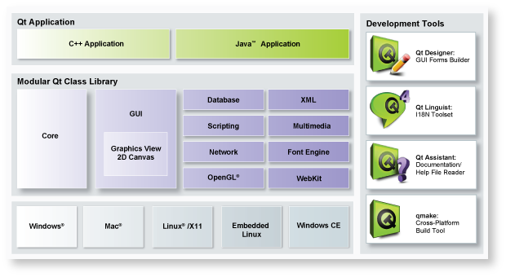

Using Eclipse 3.1.0 & CDT 3.0 for Qt 4.0.0 Development under Windows

Intro
Good things come to those, who can wait...
...finally, after years of waiting, Trolltech has released Qt4 for non commercial use under Windows.
So I decided to port my own applications to the Windows-world. Spoiled by KDevelop, the first thing I missed was a comfortabel IDE:
- Integrated debugger?
- Code completion?
- Syntax highlighting?
- Perforce support (tbd.)?
Hm, how to go? Lastly I took the QSSL way. This company is distributing the embedded OS QNX with the so called Momentics-IDE, a drilled up Eclipse-platform plus the CDT-plugin ...and it woks pretty good!
This short article summarizes what you need to download, how to configure and to install for developping your Windows Qt-applications under Eclipse with the CDT using the mingw32 environment.

Overview
To get it working, I did the following steps:
- MinGW + tools download + installation
- Qt4.0.0 for Windows download + build with mingw32
- Eclipse3.1.0 download + installation
- CDT 3.0 download + installation

MinGW
- First step is to download and execute the online installer MinGW-4.1.0.exe.
- Choose minimal package for building C/C++, full set of compiler and utilities packages. Take care, that "ming32-make" is included (Additional Tasks). I installed MinGW to "E:\MinGW".
- The installer will download ~50MB.
- Do not forget to add the "E:\MinGW\bin"-folder to your path-environment!
For test, open a dos-prompt and call mingw32-make. Normally, something like mingw32-make: *** No targets specified and no makefile found. Stop. should be prompted.

gdb from MinGW
Download and install gdb into your MinGW32-folder gdb-5.2.1-1.exe.

Qt 4.0.0
Third step is downloading the Qt/Windows Open Source Edition qt-win-opensource-desktop-4.0.0.zip , ~25MB.
- Unzip this file from trolltech: qt-win-opensource-desktop-4.0.0.zip
- Move all the files and folder under directory "qt-win-opensource-desktop-4.0.0" to a folder where you like to perform installation. In my case it was E:\Qt\4.0.0\
- Open command line and cd to that folder e.g. "cd E:\Qt\4.0.0\"
- Next type in "configure -platform win32-g++" If you need to configure further, then give the command "configure -help" and turn on/off appropriate options.
- Hit "y/Y" to accept the License agreement.
- Once Configure script ends, type in "mingw32-make"
- Pe patient, compiling Qt takes time ~1h @3GHz-AMD
- Last step is to setup a batch-file including some environments, store this file as "qtvars.bat"
  - set QMAKESPEC=win32-g++
  - set QTDIR=E:\Qt\4.0.0
  - set PATH=%QTDIR%\bin;%PATH%

Eclipse 3.1.0
Now its getting easier...
- Download eclipse-SDK-3.1-win32.zip, ~100MB.
- Unzip the archieve to root, I choosed "E:\eclipse"
- Create a workspace-folder, e.g. "D:\workspace". This will be your src-folder.
- Create a shortcut to the eclipse-executable "E:\eclipse\eclipse.exe"
- Start eclipse, enter your workspace-folder, quit.

CDT 3.0
Now Eclipse gets C/C++ functionality...
- Download org.eclipse.cdt-3.0.0-RC1-win32.x86.zip, ~100MB.
- Extract the archieve.
- Copy or move the contents of the extracted archieve into your eclipse-folder (features to features and plugins to plugins).

Configuration & Test
This was an installation spree...so let`s test it:
- Start Eclipse
- Open C/C++ Perspective (Windows -> Open Perspective -> Other -> C/C++)
- Create a new Standard C/C++ Make project called "qt_test" (File->new -> Standard C/C++ Project). Maybe you have to activate the Navigator view.
- Change the project properties for the binary parser, we have to enable the Cygwin Parser (Project -> Properties> C/C++ Make Project -> Binary Parser -> Cygwin PE Parser)
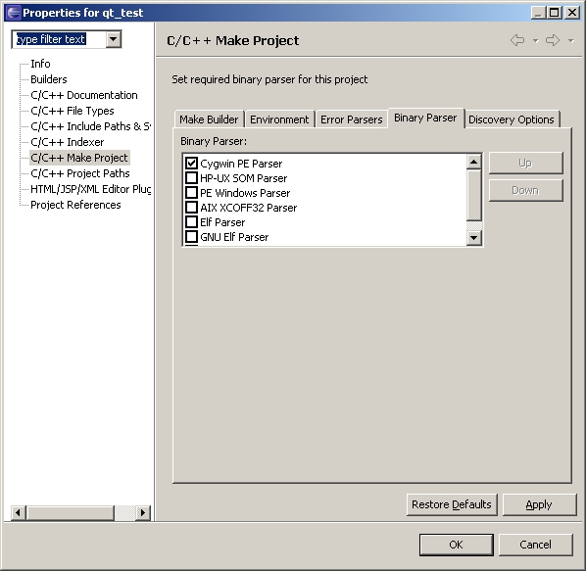
- Add two files to our project: "main.cpp" and "qt_test.pro" (File->new->Source File).
main.cpp:
#include <QApplication>
#include <QPushButton>
int main(int argc, char *argv[])
{
QApplication app(argc, argv);
QPushButton hello("QT4.0 under Eclipse");
hello.resize(100, 30);
hello.show();
return app.exec();
}
qt_test.pro:
CONFIG += qt debug
SOURCES += main.cpp
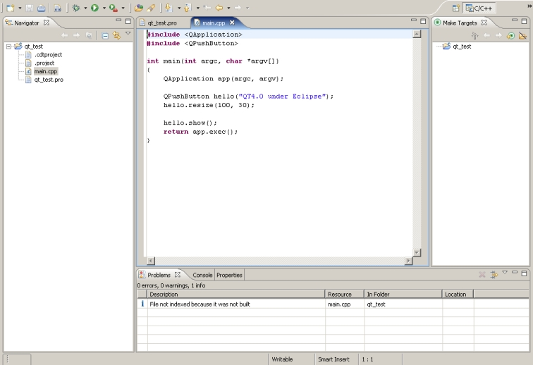
- Now we will generate a "Makefile" from "qt_test.pro" using "qmake". Because I need to add and delete files to my projects, we will create a special target for this purpose. To add a make target, right click on make targets and insert following data:
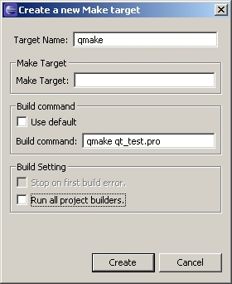
Normally, a green target should appear.
- Generate our Makefiles by double-click on the new qmake-target. Three new files should appear inside the Navigator-view:
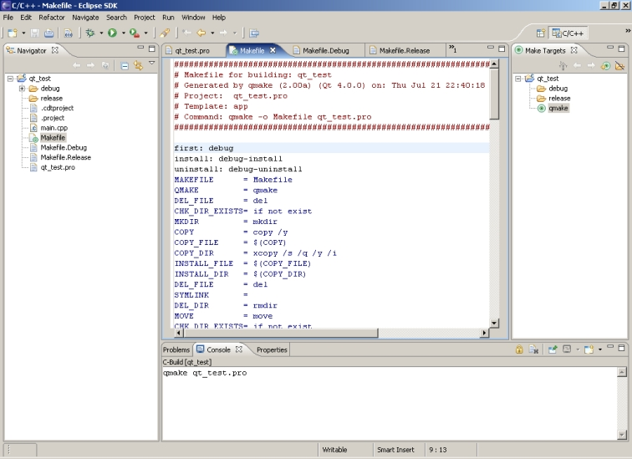
- Now we have some Makefile, so it's time to call make and gcc to build a debuggable executable. Again, add a new make-target with following settings:
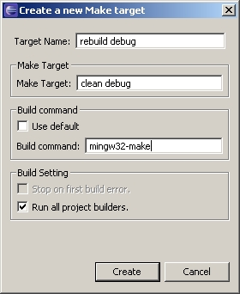
- Call the new target...and our executable will be generated:
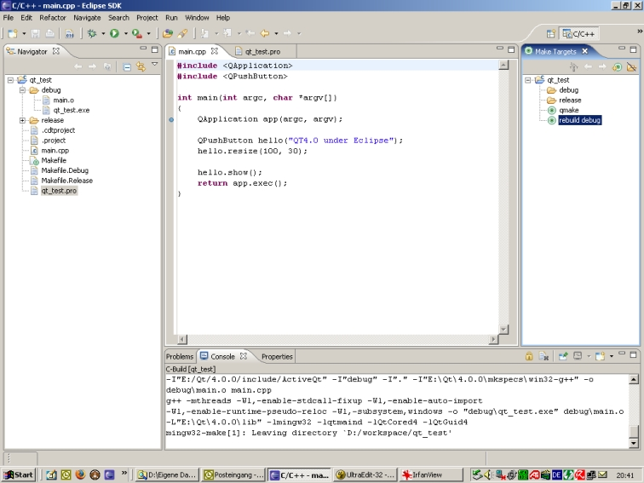
- Let's run our simple program. First, create a new Run-Configuration (Menuebar-> Run -> Run...), should be easy...
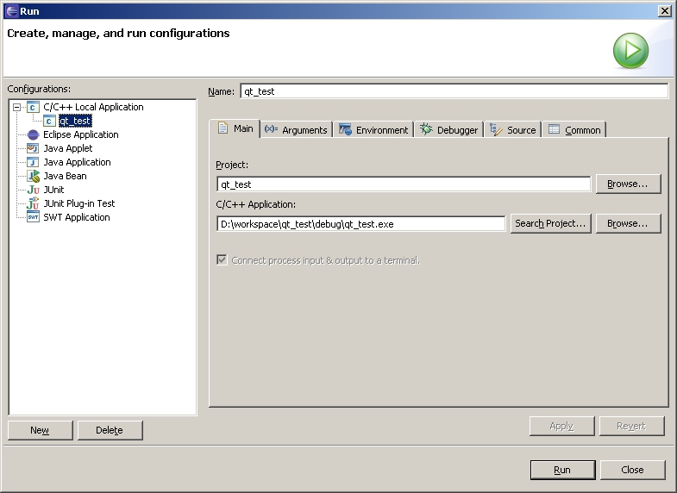
Start the program by clicking the run-button...wow
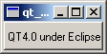
- Last thing I want to show you is how to debug. Before starting with debug, set a Breakpoint somewhere inside main.cpp by right-click on the left frame inside the editor... now add a debug-configuration (Run -> Debug...) for "C/C++ Local Application":
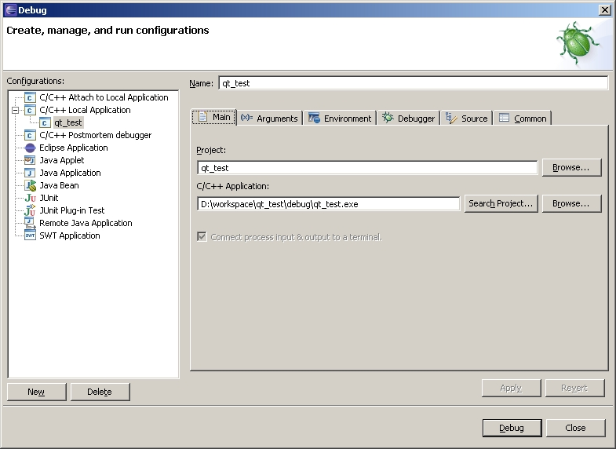
Start the debug-session (button debug), the program will be stopped at our breakpoint. Use "F6" for single-stepping.
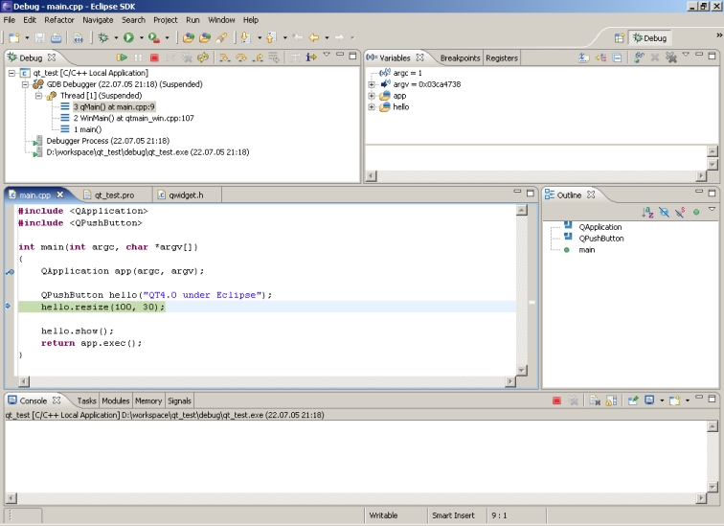
!!! Enjoy it !!!

